UPSKILL CAMPUS INTERSHIP REPORT

CODING A PORT SCANNEr IN PYTHON 3

NAME : R.P.SUJITH

DEPT : CSE

INTERSHIP  **:** Cybersecurity

Copyright

No part of this publication, in whole or in part, may be reproduced, copied, transferred or any other right reserved to its copyright owner, including photocopying and all other copying, any transfer or transmission using any network or other means of communication, any broadcast for distant learning, in any form or by any means such as any information storage, transmission or retrieval system.

**Project Name:** Multi-Port Network Scanner

**Project Goal:**

The goal of this project is to create a simple network scanner that can check the status of multiple ports on one or more target IP addresses.

The scanner will identify which ports are open on the specified targets.

### Project Objective:

The objective of this project is to create a network port scanner that can identify open ports on specified targets. The scanner should:

1. Accept multiple target IP addresses or domain names.
2. Allow the user to specify how many ports to scan on each target.
3. Provide clear and concise output indicating which ports are open.
4. Be simple to use and modify for different scanning needs.

CODE :

import socket

from termcolor import colored

def scan(target, ports):

print('\n' + ' Starting Scan For ' + str(target))

for port in range(1, ports + 1): # Changed range to include the 'ports' value

scan_port(target, port)

def scan_port(ipaddress, port):

try:

sock = socket.socket()

sock.settimeout(1) # Set timeout to prevent long wait times

sock.connect((ipaddress, port))

print(colored("[+] Port Opened " + str(port), 'green'))

sock.close()

except:

pass

targets = input("[*] Enter Targets To Scan (split them by ,): ")

ports = int(input("[*] Enter How Many Ports You Want To Scan: "))

if ',' in targets:

print(colored("[*] Scanning Multiple Targets", 'green'))

for ip_addr in targets.split(','):

scan(ip_addr.strip(' '), ports)

else:

scan(targets, ports)

### Step-by-Step Explanation of the Code

Let's go through the code step by step and explain each part in detail. We will also demonstrate the scanning process using a real-time website example.

### Explanation of Code:

The code is designed to perform a network port scan on one or multiple targets, identifying which ports are open.

#### 1. Imports:

* socket: Allows the code to create socket objects for network communication.
* termcolor: Provides colored terminal output to enhance readability.

#### 2. Functions:

* **scan(target, ports)**:
  + **Purpose**: Scans the specified number of ports on the target.
  + **Parameters**:
    - target: The IP address or domain name to scan.
    - ports: The number of ports to scan.
  + **Operation**: Loops through the port numbers from 1 to ports and calls scan_port for each.
* **scan_port(ipaddress, port)**:
  + **Purpose**: Attempts to connect to a specific port on the target.
  + **Parameters**:
    - ipaddress: The IP address or domain name of the target.
    - port: The port number to scan.
  + **Operation**: Creates a socket and tries to connect to the target on the specified port. If successful, prints a message indicating the port is open. Closes the socket after checking.

#### 3. Main Script:

* Prompts the user to input targets and the number of ports to scan.
* Checks if multiple targets are specified (comma-separated).
  + If multiple targets, scans each target individually.
  + If a single target, scans that target.
* Uses colored output to indicate scanning status and results.

#STEP TO DEPLOY PROJECT:

1.Downloading Virtual Box And Kali Linux

where we can download the Kali Linux Operating System And Virtual Box.

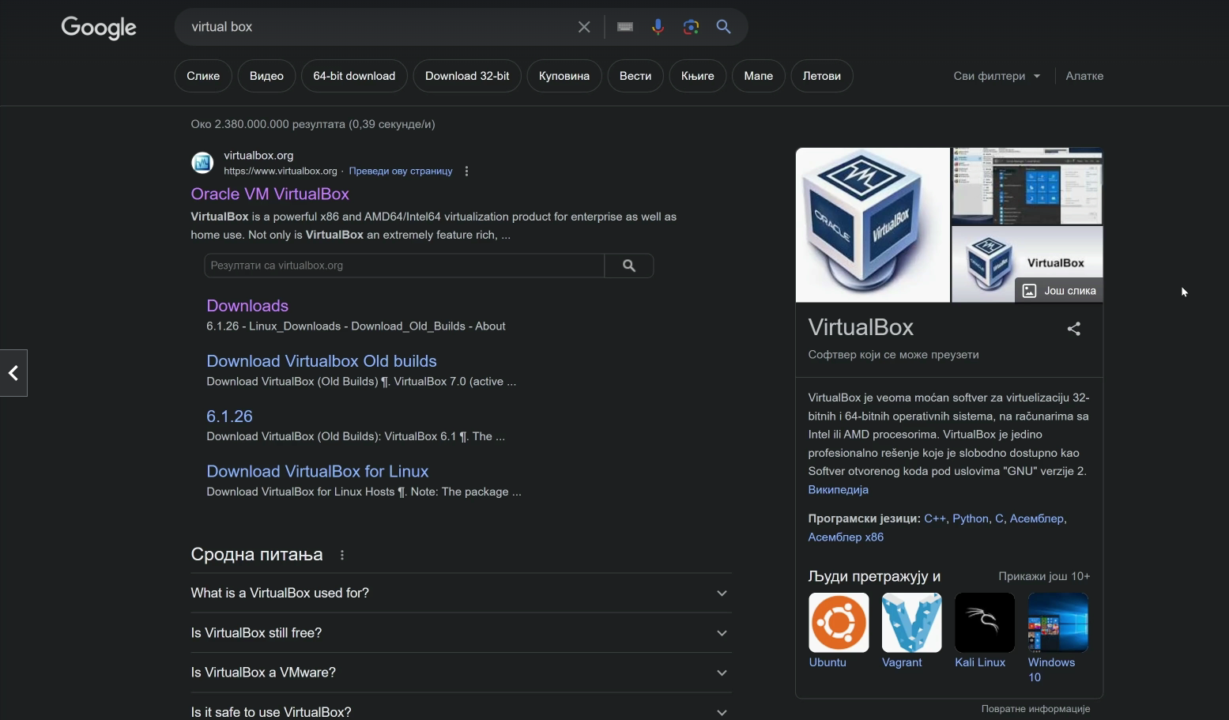

Download



Installing kali linux

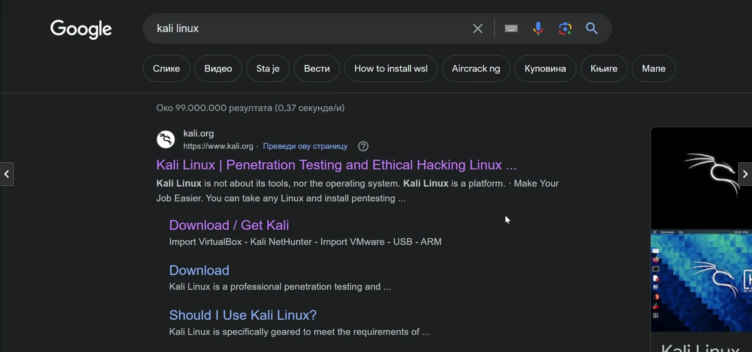





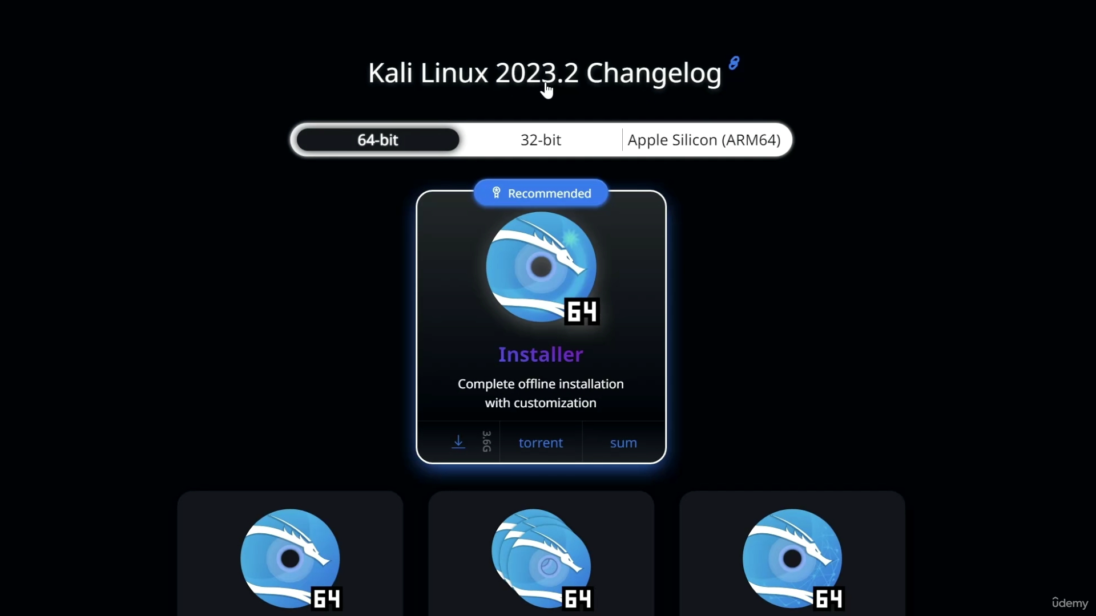



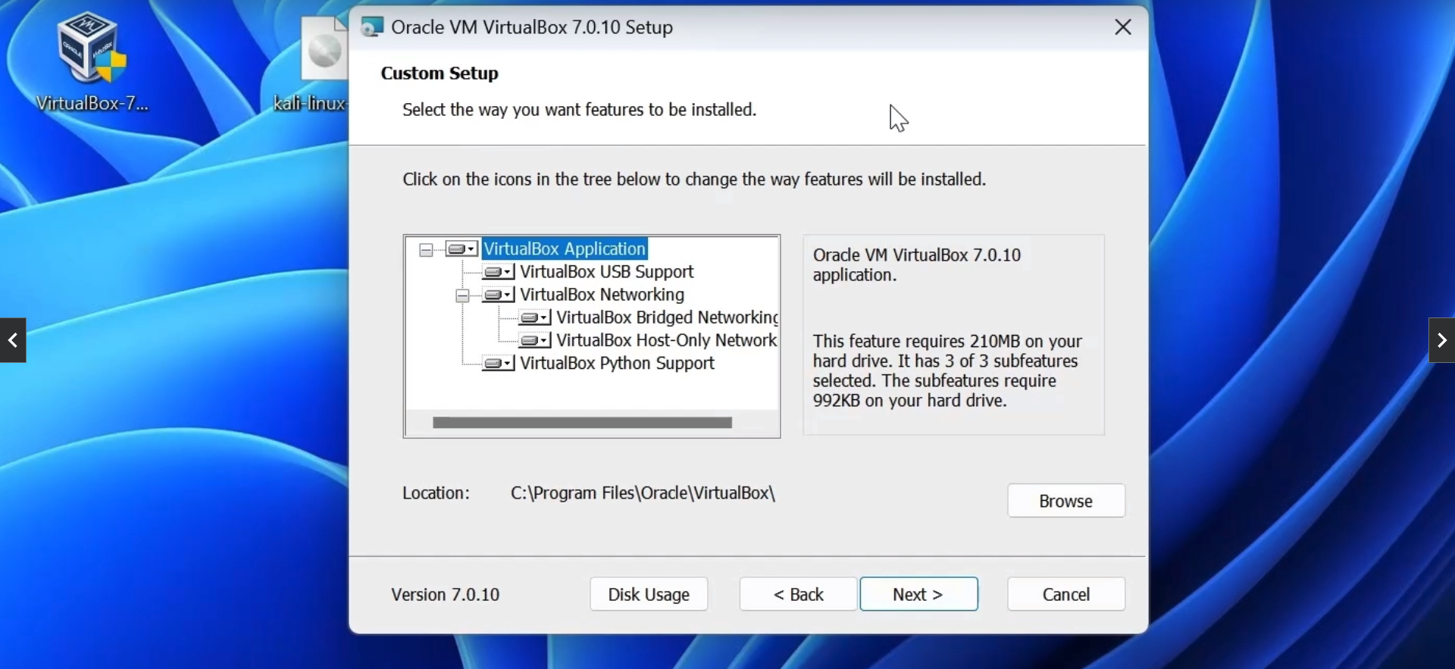

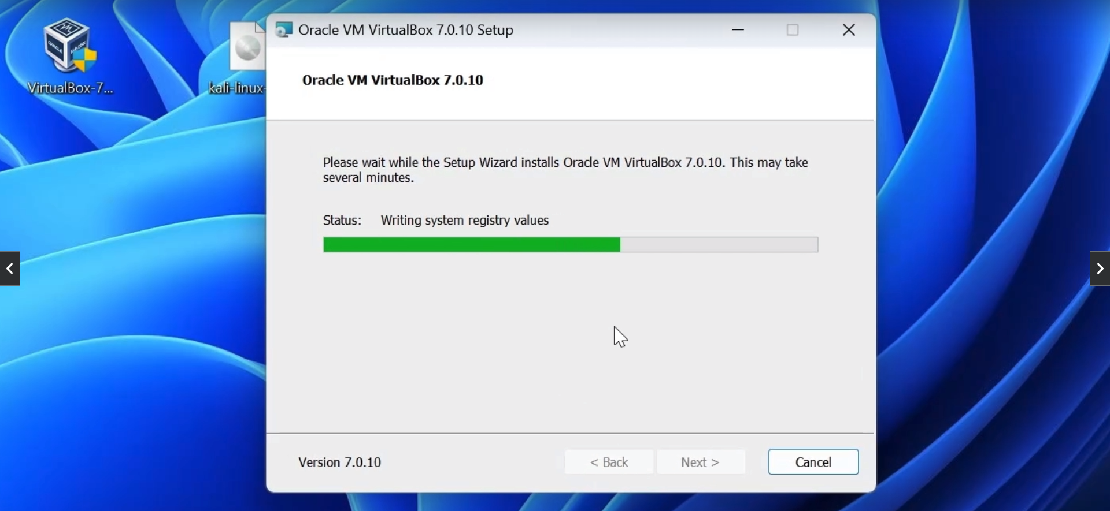

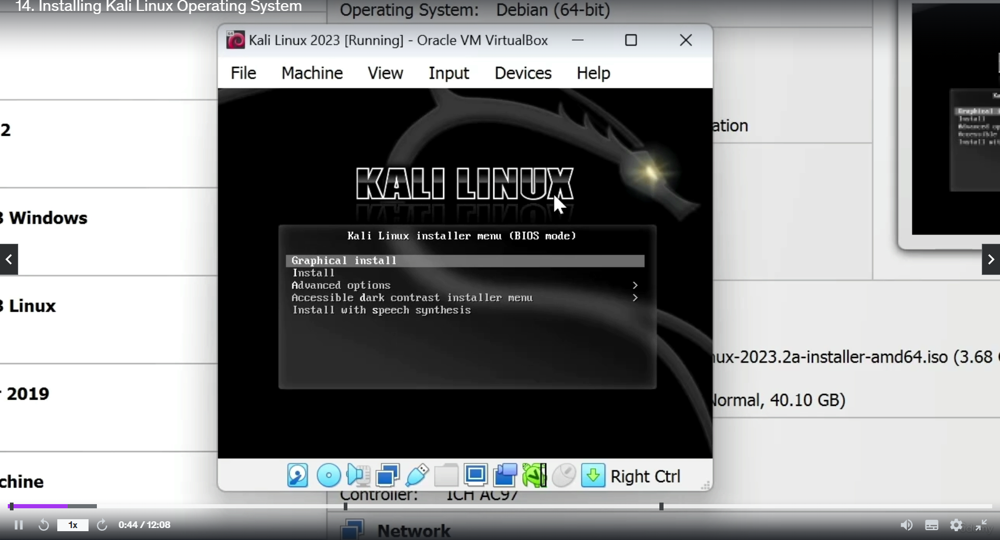

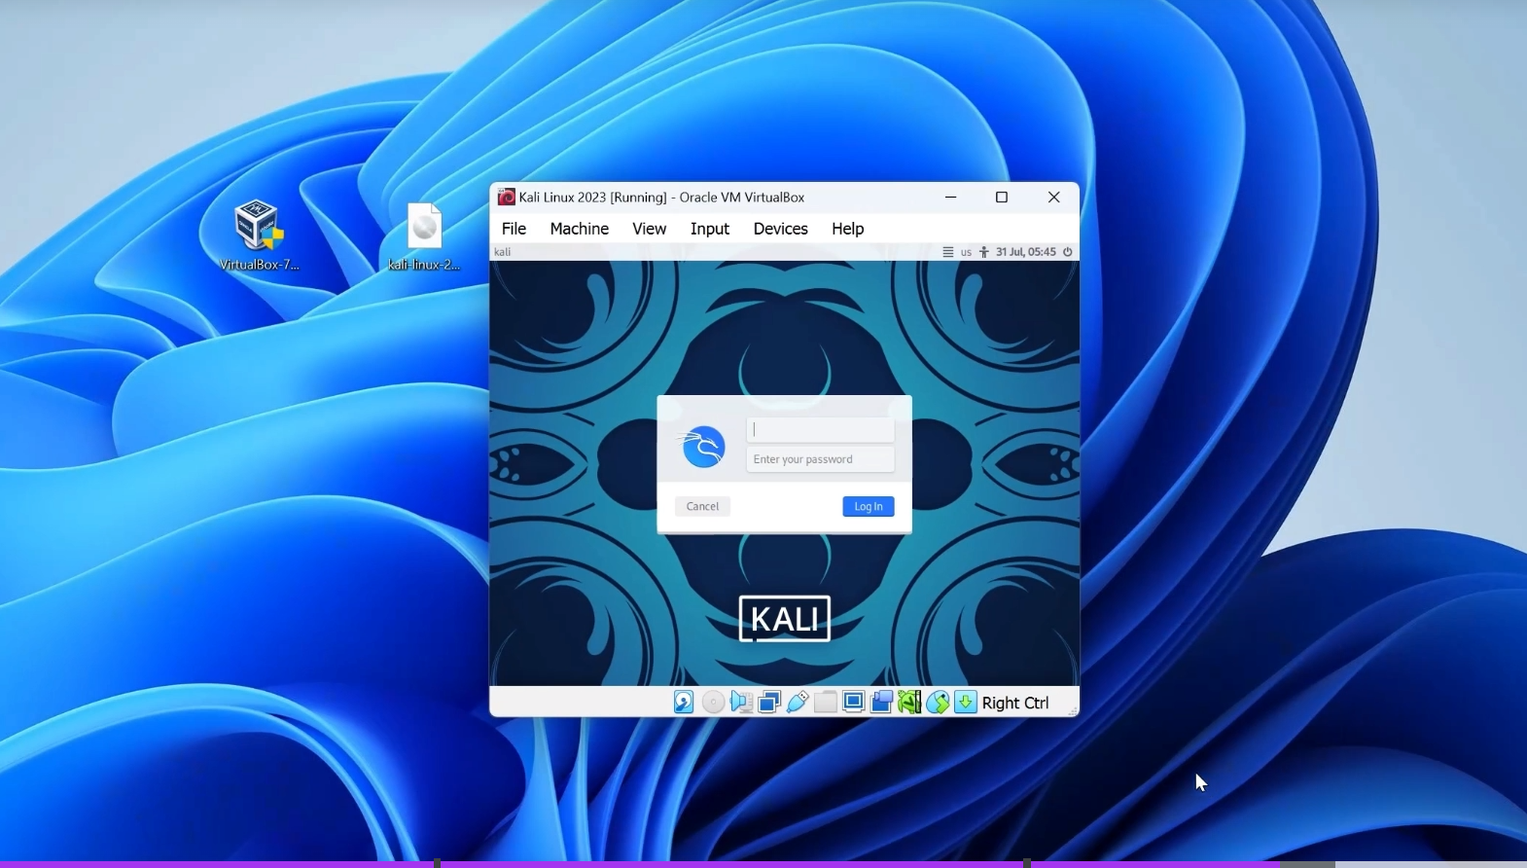

**OUTPUT:**

**[*] Enter Targets To Scan (split them by ,): scanme.nmap.org**

**[*] Enter How Many Ports You Want To Scan: 10**

**[*] Enter Targets To Scan (split them by ,): scanme.nmap.org**

**[*] Enter How Many Ports You Want To Scan: 10**

**Starting Scan For scanme.nmap.org**

**[+] Port Opened 22**

**[+] Port Opened 80**